**Anaconda Installation Instructions for Macs and Windows:**

1. Go to [www.anaconda.com/download](http://www.anaconda.com/download)

2. Click on the Python 3.7 64-Bit Graphical Installer version:

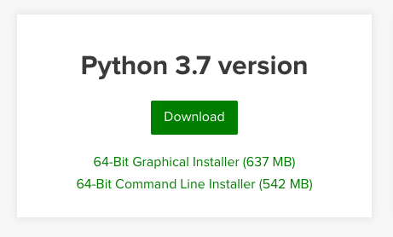

3. Enter your email to download.

4. You’ll see something like this at the bottom of your browser after it finishes downloading (Windows users will see EXE instead of PKG). Click on it:

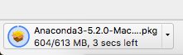

5. Press Next/Continue and Agree a few times to install. You may need to type in your system password to proceed.

On Windows, things will look like this:

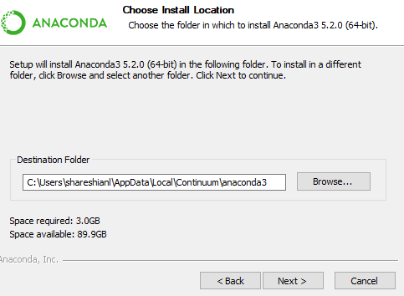

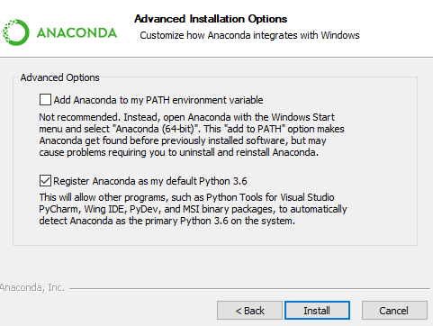

6. On either a Mac or Windows, you don’t need to install VS. You can press continue to skip that part:

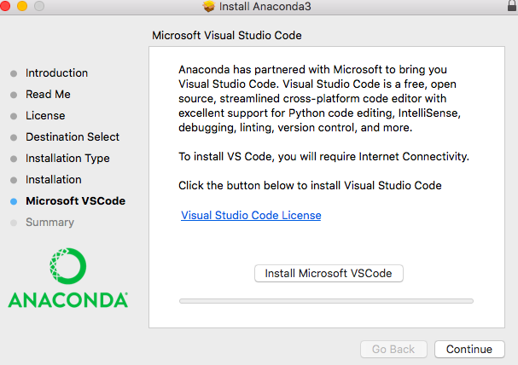

7. On a Mac, you can move the installer to the trash:

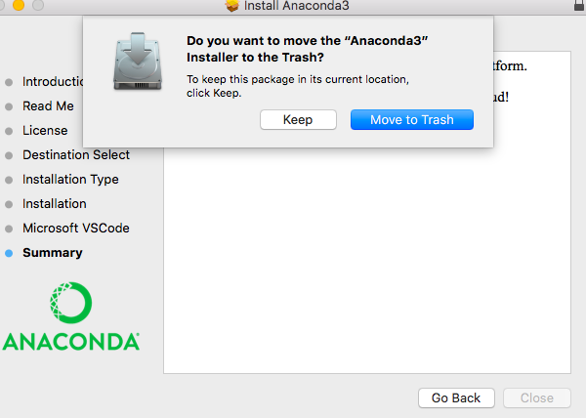

You should have Anaconda now!

**Using Anaconda**

1. On Windows, go to Programs – Anaconda3 – Jupyter Notebook.

On Mac, it’s a two step process. Go to Applications – Anaconda. It should look like this:

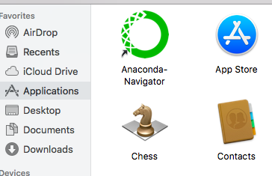

Launch the green Anaconda-Navigator and then select the orange Jupyter notebook:

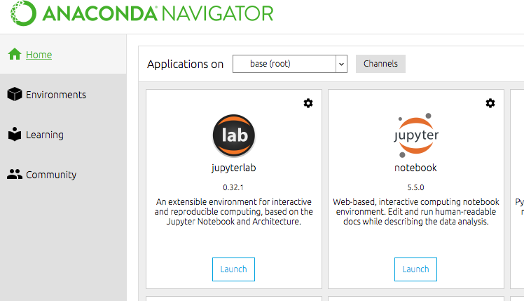

2. On either machine, a browser should pop open that looks something like this:

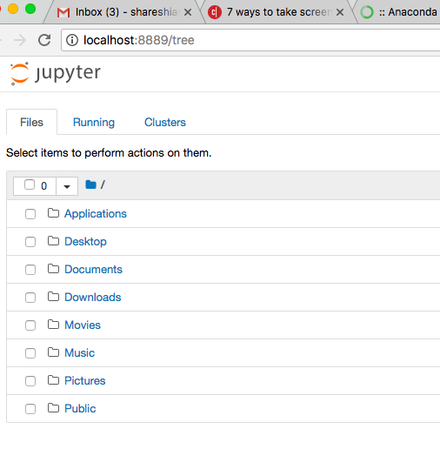

3. If you wanted to create a new Jupyter Notebook file to program in, you could select New – Python 3 in the top right:

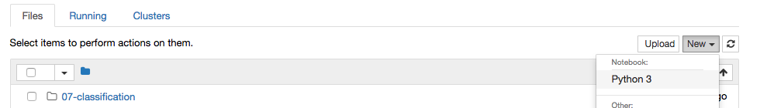

4. Then you could start coding:

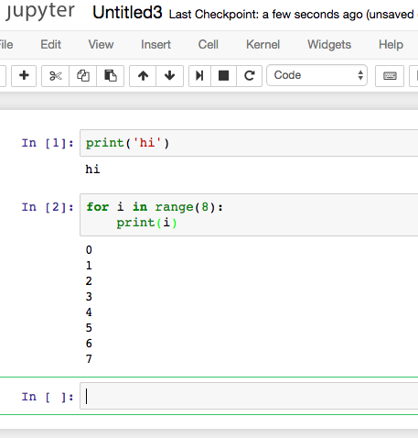

5. If you wanted to open up my Python Intro notebook, you could download it from Google Drive and save it in your Documents folder. Then, navigate to your Documents folder through this open browser to see it:

